MILESTONE 1: CLIENT DESIGN REVIEW - CMPG325-2026-063

Date: 28 August 2026
Client: Phenyo Cultural Tours (Potchefstroom)
Student: 46898064

- CLIENT REQUIREMENTS
Organisation Type: Tourism - Cultural Tours, Bookings, Guided Experiences Business Needs Identified:
- Booking & Reservations desk (30 users) - needs access to Web booking system, fast internet, printer.
- Tour Operations / Guides (30 users) - mobile laptops, shared files.
- Finance & Admin (15 users) - highly confidential, isolated.
- Marketing (15 users) - media uploads, social media.
- Server Farm - Website www.phenyotours.co.za, DNS, DHCP, Email.
- Guest Wi-Fi for customers in lounge (60 users) - isolated from staff network.

Technical Constraints from Brief:
- Constraint: All device administration must be secured - Previous incident of unauthorised changes. -> Solution: enable secret, service password-encryption, console/VTY passwords, SSH only, local admin account, banner.
- Challenge: Port Security (Foundational - switchport access control) -> Solution: Sticky MAC, max 2 MACs per access port, violation restrict.
- CR5: User numbers grow by 25% without renumbering -> Solution: VLSM over-provisioning with slack in each subnet + reserve subnet.

Addressing Block: 172.30.38.0/23 = 255.255.254.0 = 172.30.38.0 to 172.30.39.255 (510 usable)

- PHYSICAL TOPOLOGY

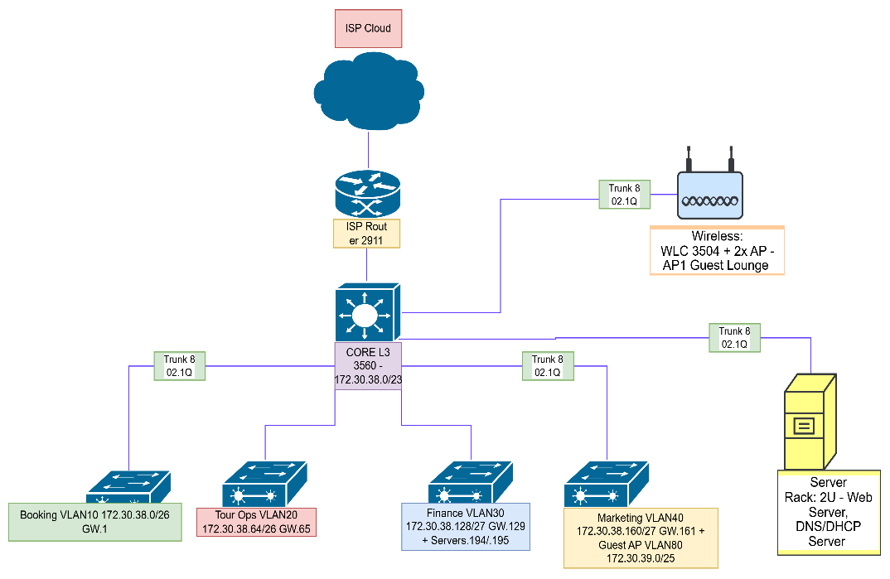

Physical Layout:

- Building: Single HQ in Potchefstroom with 4 departments
- Cabinet: Core L3 Switch 3560 as central point, ISP Router 2911 for Internet
- Access: 4x Cisco 2960 Switches - One per department
- SW1 Booking -> 10x desktops + printer
- SW2 Tour Ops -> 12x laptops
- SW3 Finance -> 8x desktops
- SW4 Marketing -> 10x desktops
- Server Rack: 2U - Web Server, DNS/DHCP Server connected to Finance switch but in VLAN 99.
- Wireless: WLC 3504 + 2x AP - AP1 Guest Lounge (SSID Phenyo-Guest), AP2 Staff (SSID Phenyo-Staff)
- Cabling: All inter-switch links are GigabitEthernet Trunk (802.1Q), Access ports FastEthernet

LOGICAL TOPOLOGY

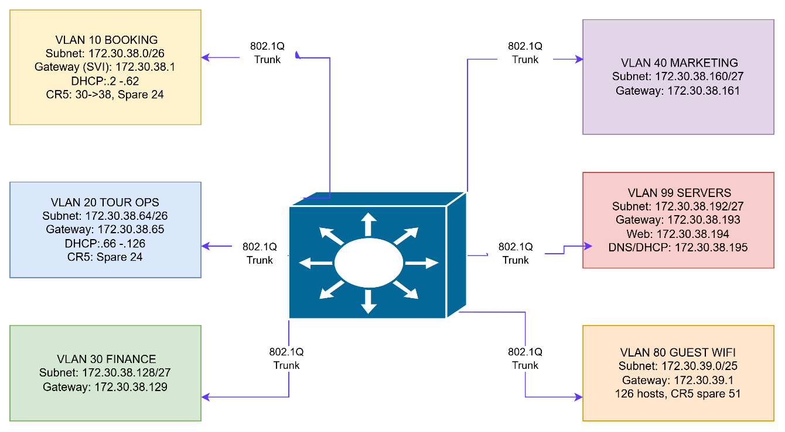

VLAN ID | VLAN Name | Subnet Gateway | IP(SVI) | Subnet Mask Host Range | DHCP Pool
10 | Booking | 172.30.38.0/26 | 172.30.38.1 | 255.255.255.192 (/26) | 172.30.38.2-172.30.38.62
20 | Tour Operations | 172.30.38.64/26 | 172.30.38.65 | 255.255.255.192 (/26) | 172.30.38.70-172.30.38.126
30 | Finance | 172.30.38.128/26 | 172.30.38.129 | 255.255.255.224 (/27) | 172.30.38.130-172.30.38.158
40 | Marketing | 172.30.38.160/26 | 172.30.38.161 | 255.255.255.224 (/27) | 172.30.38.162-172.30.38.190
99 | Severs | 172.30.38.192/26 | 172.30.38.193 | 255.255.255.224 (/25) | 172.30.38.196-172.30.38.222

VLAN Design:

- VLAN 10 - BOOKING - 172.30.38.0/26
- VLAN 20 - TOURS - 172.30.38.64/26
- VLAN 30 - FINANCE - 172.30.38.128/27
- VLAN 40 - MARKETING - 172.30.38.160/27
- VLAN 99 - SERVERS - 172.30.38.192/27
- VLAN 80 - GUEST WIFI - 172.30.39.0/25
- VLAN 1 - MGMT - 172.30.39.128/25 (unused for users)

Routing: Inter-VLAN routing on Core L3 using SVIs as default gateways. All Access switches use 802.1Q trunks to Core.

Services:
- Centralized DHCP on 172.30.38.195 serving all VLANs via ip helper-address
- DNS local: phenyotours.local
- Web: 172.30.38.194 -> www.phenyotours.co.za

4. IP ADDRESSING PLAN - VLSM WITH CR5 PROOF

VLAN | Dept | Current | +25% =Required | Allocated Subnet | Mask | Usable | Range | Gateway | Spare CR5
10 | Booking | 30 | 38 | 172.30.38.0/26 | 255.255.255.192 | 62 | .2-.62 | 172.30.38.1 | +24
20 | Tour Ops | 30 | 38 | 172.30.38.64/26 | .192 | 62 | .66-.126 | 172.30.38.65 | +24
30 | Finance | 15 | 19 | 172.30.38.128/27 | .224 | 30 | .130-.158 | 172.30.38.129 | +11
40 | Marketing | 15 | 19 | 172.30.38.160/27 | .224 | 30 | .162-.190 | 172.30.38.161 | +11
99 | Servers | 10 | 13 | 172.30.38.192/27 | .224 | 30 | .194-.222 | 172.30.38.193 | +17
80 | Guest | 60 | 75 | 172.30.39.0/25 | .128 | 126 | .2-.126 | 172.30.39.1 | +51
1 | Mgmt | 10 | 13 | 172.30.39.128/25 | .128 | 126 | .130-.254 | 172.30.39.129 | +113
Reserve | Future |  |  | 172.30.38.224/27 | .224 | 30 |  |  | CR5 buffer

CR5 Verification: Total required after growth = 202 hosts. Total allocated capacity = 406 hosts + 126 Mgmt + 30 Reserve = 562. Original block gives 510. No renumbering needed - only need to use DHCP from reserve pool.

https://github.com/musanicholas100-arch/CMPG325-2026-063-Phenyo-Cultural-Tours/tree/main

